Jenkins challenges-2

Create a Declarative Jenkins parameterized pipeline for simplecustomerapp.
Requirements:
- Create a Pipeline job in Jenkins.
- Use a Git repository for simplecustomerapp.
- Add parameters:
• BRANCH_NAME (string, default: main)
• ENV (choice: dev, qa)
- Define environment variables:
• APP_NAME = simplecustomerapp
- Implement stages:
• Checkout (based on BRANCH_NAME)
• Build (mvn clean compile)
• Test (mvn test)
• Package (mvn package)
- Add post actions:
• Success → print success message with environment
• Failure → print failure message
Trigger using Build with Parameters.
- CHOICE PARAMETER
- STRING PARAMETER
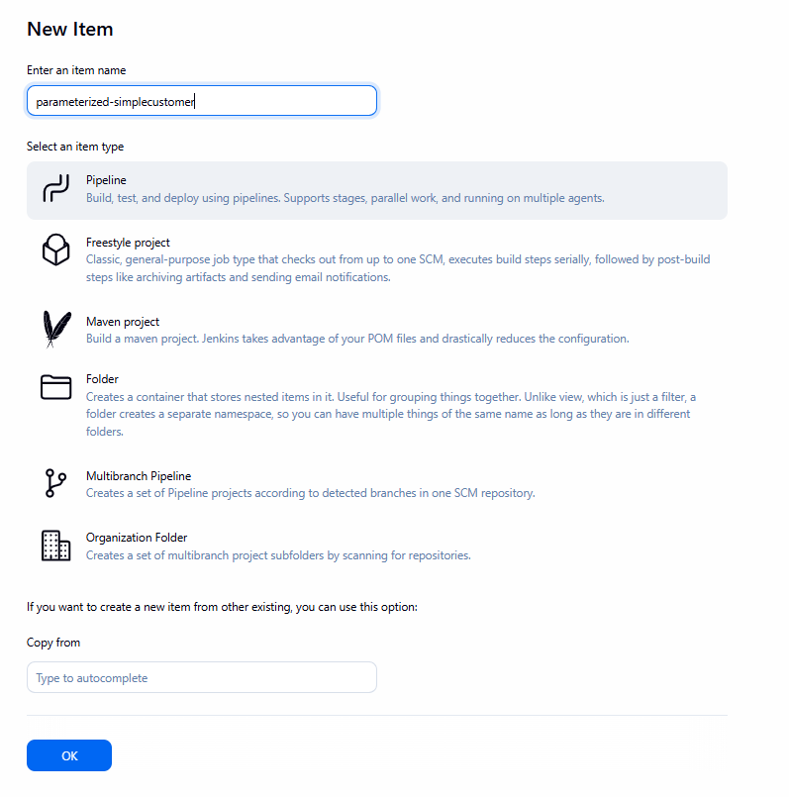
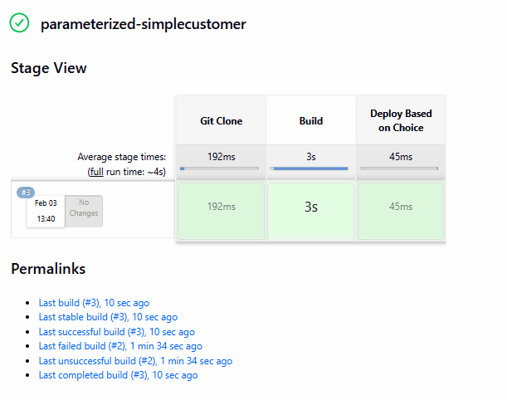
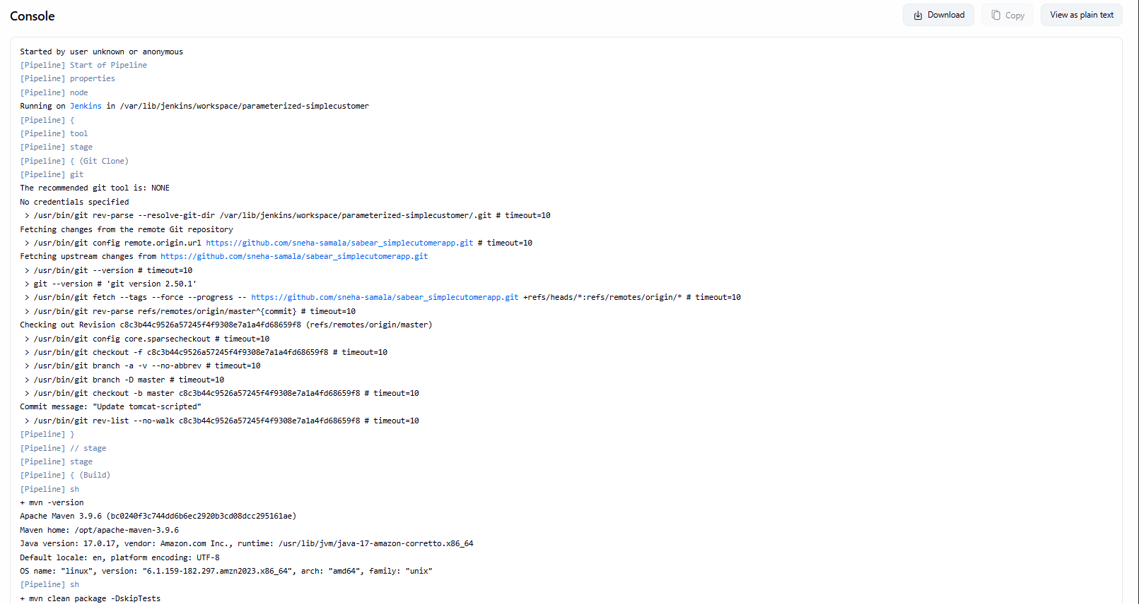
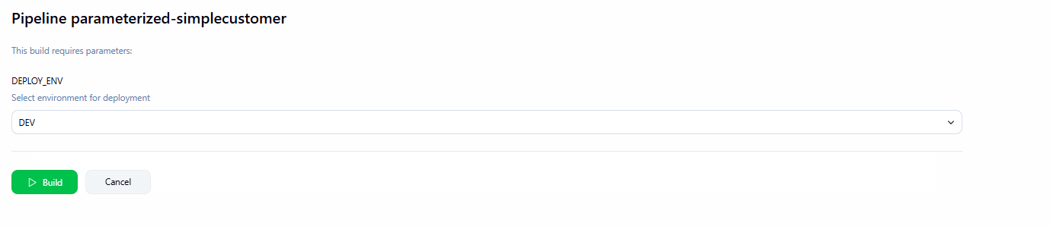
Code
/* ========= PARAMETERS ========= */
properties([
parameters([
choice(
name: 'DEPLOY_ENV',
choices: ['DEV', 'QA', 'PROD'],
description: 'Select environment for deployment'
)
])
])

node {

/* ========= LOAD MAVEN TOOL ========= */
def mvnHome = tool name: 'MVN_HOME', type: 'maven'
env.PATH = "${mvnHome}/bin:${env.PATH}"

stage('Git Clone') {
git branch: 'master',
url: 'https://github.com/sneha-samala/sabear_simplecutomerapp.git'
}

stage('Build') {
sh 'mvn -version'
sh 'mvn clean package -DskipTests'
}

stage('Deploy Based on Choice') {

if (params.DEPLOY_ENV == 'DEV') {
echo 'Deploying to DEV environment'
}
else if (params.DEPLOY_ENV == 'QA') {
echo 'Deploying to QA environment'
}
else if (params.DEPLOY_ENV == 'PROD') {
echo 'Deploying to PROD environment'
}
}
}

